4.

(1)

large = 'mandrill-large.tiff';

filename = large;

A = double(imread(filename));

imwrite(uint8(round(A)), 'p4\_1.tiff');

C:\Users\wayne\AppData\Local\Microsoft\Windows\INetCache\Content.Word\p4_1.tiff

(2)

k = 16; nIters = 40;

filename = small;

[m, kgroup] = myKmeans(filename, k, nIters);

function [ m, kgroup] = myKmeans(filename, k, nIters)

%%

color\_scale = 256;

im = double(imread(filename));

[rows, cols, dim] = size(im);

m = floor(color\_scale \* rand(dim, k));

kgroup = zeros(rows, cols);

for h = 1:nIters

kgroup = findClosestCenterOf(kgroup, im, m);

m = findMeans(kgroup, im, m, k);

format long

disp(['percentage: ', num2str(round(h / nIters \* 100)) , '%']);

end

%%

function m = findMeans(kgroup, im, m, k)

for l = 1:k

[row, col] = find(kgroup == l);

if ~isempty(row)

count = 0;

for i = 1:length(row)

count = count + 1;

m(:, l) = m(:, l) + squeeze(im(row(i), col(i),:));

end

m(:, l) = m(:, l)/ count;

end

end

end

end

function kgroup = findClosestCenterOf(kgroup, im, m)

k = size(m, 2);

for i = 1:size(im, 1)

for j = 1:size(im, 2)

tmp = zeros(1, k);

for l = 1:k

tmp(l) = norm(squeeze(im(i, j, :)) - m(:, l), 2);

end

[~,I] = min(tmp);

kgroup(i, j) = I;

end

end

end

(3)

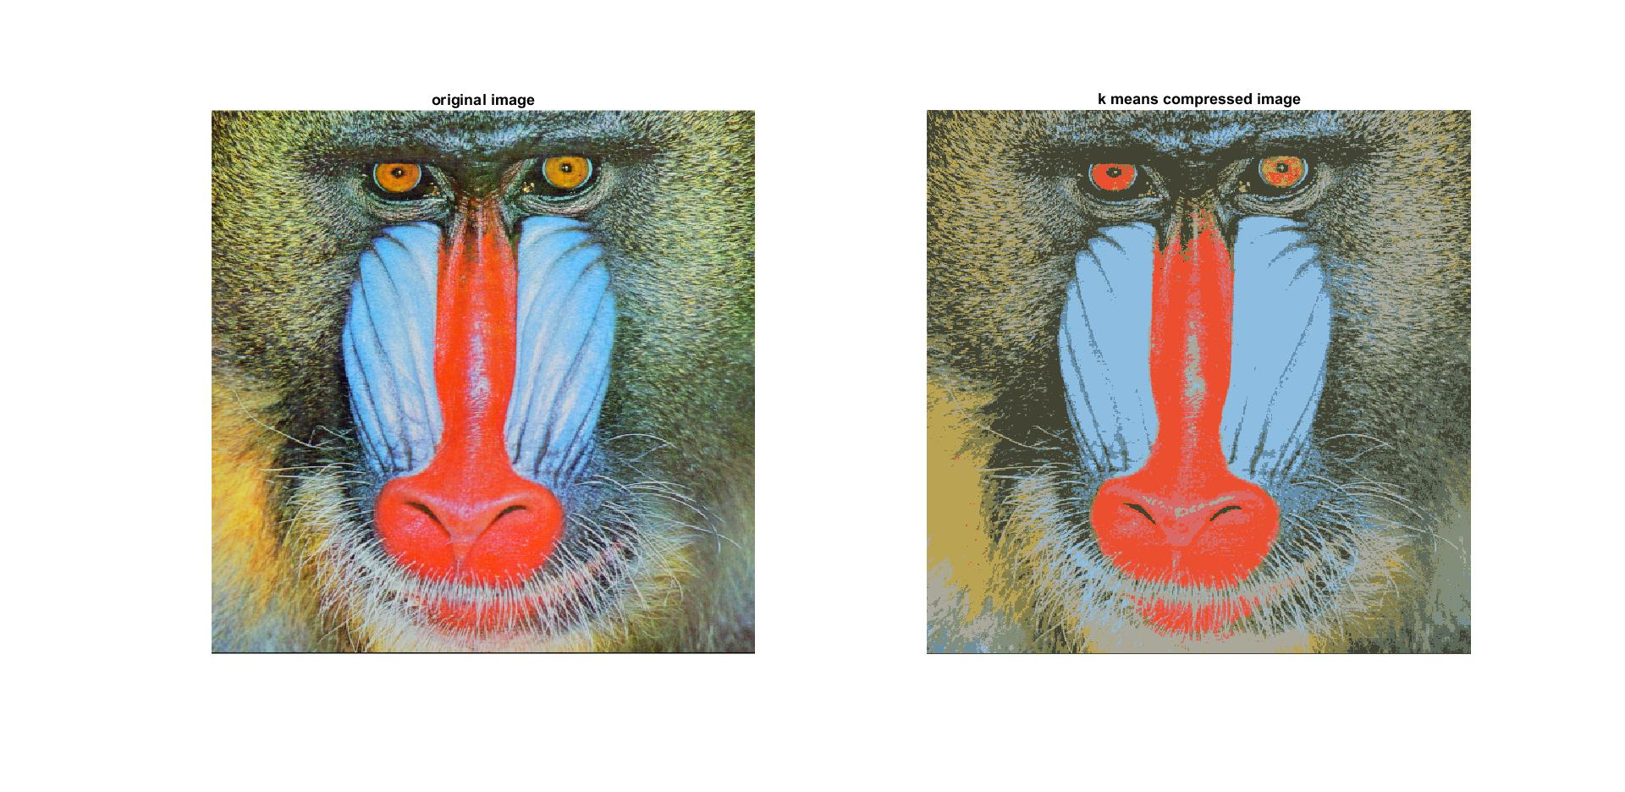

filename = large;

A = double(imread(filename));

image = compress(m, A);

figure,

subplot(1,2,1),

imshow(uint8(A));

title('original image');

subplot(1,2,2),

imshow(image);

title('k means compressed image');

function image = compress(m, im)

[rows, cols, dim] = size(im);

image = zeros(rows, cols, dim);

kgroup = zeros(rows, cols);

kgroup = findClosestCenterOf(kgroup, im, m);

for i = 1:rows

for j = 1:cols

idx = kgroup(i, j);

image(i, j, :) = reshape(m(:, idx), [1, 1, dim]);

end

end

image = uint8(image);

end

(4)

Each pixel in the original image has the value from 0 to 256 on RGB. Therefore, it cost 24 bits per pixel. On the other hand, the kmeans only need to save the value of cluster from 0 to 16, which only costs 4 bits. As a result, if we assume that the means are the same for all the images and ignore them on calculating compressed factor. We use only of the original image after compression.

(4)

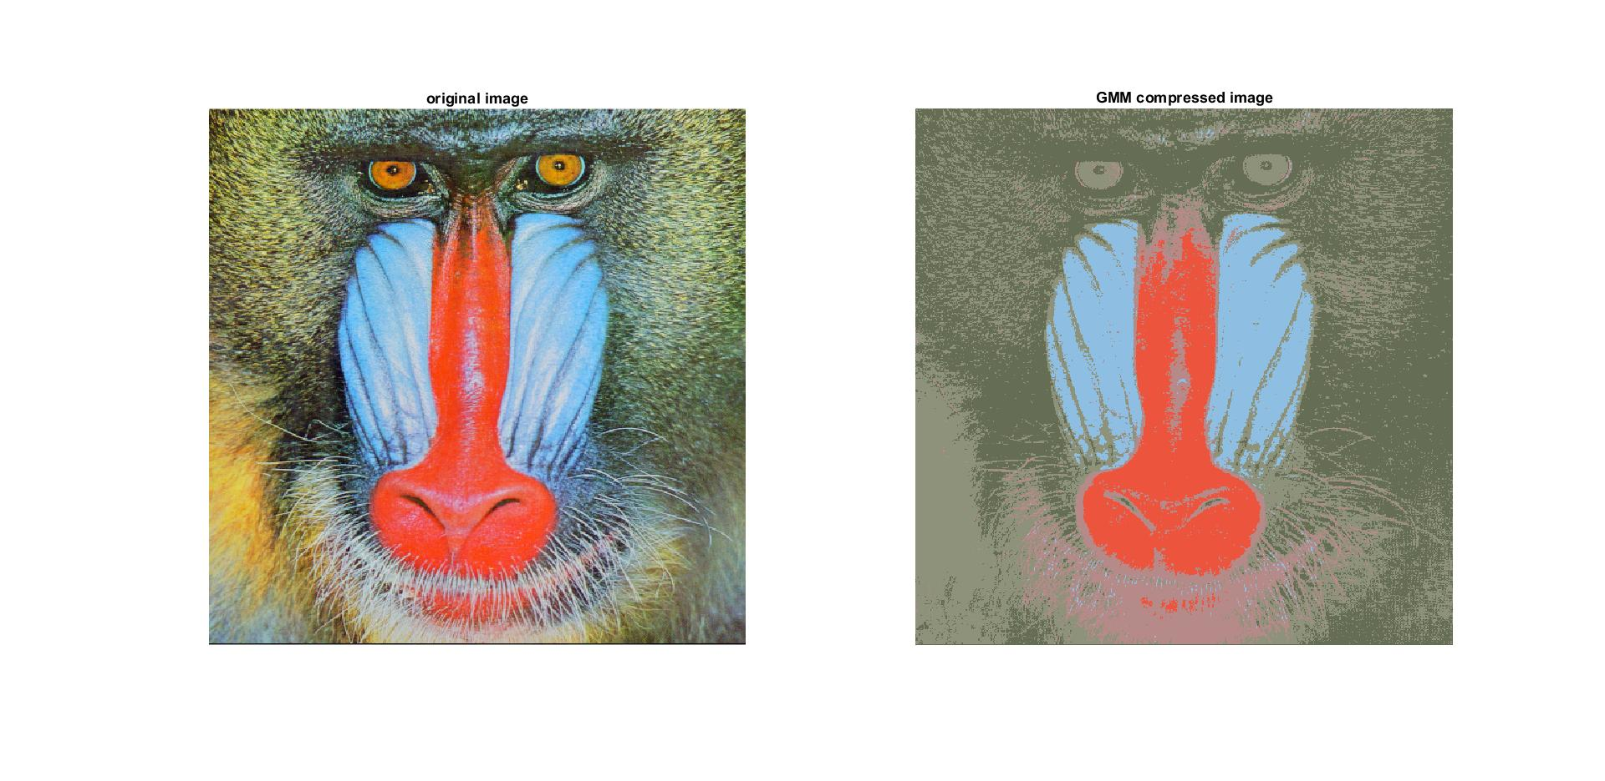

We use 3 bits to store the MAP estimate for each pixel. In GMM, We use of the original image after compression.

|  |  |  |  |
| --- | --- | --- | --- |
|  |  | | |
| K | R | G | B |
| 1 | 181.577695440685 | 137.930878010427 | 135.850026990273 |
| 2 | 141.791300841145 | 146.007393447149 | 122.277218588609 |
| 3 | 237.362424634810 | 84.1546764501801 | 61.9142384005461 |
| 4 | 141.583117117354 | 190.533438387129 | 226.278000572344 |
| 5 | 100.809940463799 | 110.026302800986 | 84.8502275241879 |

|  |  |  |
| --- | --- | --- |
|  | | |
| 110.94 | 948.9 | 32.6 |
| 948.9 | 1156.5 | 403.1 |
| 32.5 | 403.2 | 594.4 |

|  |  |  |
| --- | --- | --- |
|  | | |
| 815.91 | 644.31 | 251.73 |
| 644.31 | 658.33 | 446.36 |
| 251.73 | 446.36 | 891.47 |

|  |  |  |
| --- | --- | --- |
|  | | |
| 195.65 | -154.88 | 321.65 |
| -154.88 | 334.52 | 584.75 |
| 321.65 | 584.75 | 1245.6 |

|  |  |  |
| --- | --- | --- |
|  | | |
| 412.39 | 456.29 | 278.17 |
| 456.29 | 604.71 | 417.85 |
| 278.17 | 417.85 | 391.82 |

|  |  |  |
| --- | --- | --- |
|  | | |
| 920.57 | 13.93 | -463.68 |
| 13.93 | 801.55 | 1047.13 |
| -463.68 | 1047.13 | 1693.85 |

k = 5;

nIters = 100;

filename = small;

[m, sigma, prior] = gmm(filename, k, nIters);

filename = large;

A = double(imread(filename));

[rows, cols, dim] = size(A);

W = expectation(reshape(A, [rows \* cols, dim]), m, k, sigma, prior);

image = zeros(rows, cols, dim);

for i = 1:rows

for j = 1:cols

idx = (i - 1) \* cols + j;

[~, I] = max(W(idx, :));

image(j, i, :) = reshape(m(I, :), [1, 1, dim]);

end

end

image = uint8(image);

figure,

subplot(1,2,1),

imshow(uint8(A));

title('original image');

subplot(1,2,2),

imshow(image);

title('GMM compressed image');

function [m, sigma, prior] = gmm( filename, k, nIters )

%GMM Summary of this function goes here

% Detailed explanation goes here

im = double(imread(filename));

[rows, cols, dim] = size(im);

X = reshape(im, [rows \* cols, dim]);

%% initialization

indeces = randperm(rows \* cols);

m = X(indeces(1:k), :);

sigma = zeros(dim, dim, k);

% Use the overal covariance of the dataset as the initial variance for each cluster.

for i = 1:k

sigma(:, :, i) = cov(X);

end

% Assign equal prior probabilities to each cluster.

prior = ones(1, k) \* (1 / k);

%% EM

for h = 1:nIters

prevM = m;

W = expectation( X, m, k, sigma, prior);

[prior, m, sigma ] = maximization(m, W, X, k, prior, sigma);

if m == prevM

break

end

end

end

function W = expectation( X, m, k, sigma, prior)

[row, n] = size(X);

pdf = zeros(row, k);

for i = 1 : k

Sigma = sigma(:, :, i);

meanDiff = bsxfun(@minus, X, m(i, :));

pdf(:, i) = 1 / sqrt((2\*pi)^n \* det(Sigma)) \* exp(-1/2 \* sum((meanDiff / Sigma .\* meanDiff), 2));

end

pdf\_w = bsxfun(@times, pdf, prior);

W = bsxfun(@rdivide, pdf\_w, sum(pdf\_w, 2));

end

function [prior, m, sigma ] = maximization(m, W, X, k, prior, sigma)

[row, n] = size(X);

for i = 1 : k

prior(i) = mean(W(:, i), 1);

% Divide by the sum of the weights.

m(i, :) = (W(:, i)' \* X) ./ sum(W(:, i), 1);

sigma\_k = zeros(n, n);

meanDiff = bsxfun(@minus, X, m(i, :));

for j = 1 : row

sigma\_k = sigma\_k + (W(j, i) .\* (meanDiff(j, :)' \* meanDiff(j, :)));

end

sigma(:, :, i) = sigma\_k ./ sum(W(:, i));

end

end